Homework: Fine Tuning for Text Classification
Chris Winsor 4/15/2023 COMP5300

We fine-tuned "bert-base-uncased" for three GLUE tasks: CoLA, MNLI and MRPC.

For the application head we used Softmax with 3 nonlinear layers on the pretrained Bert backbone.
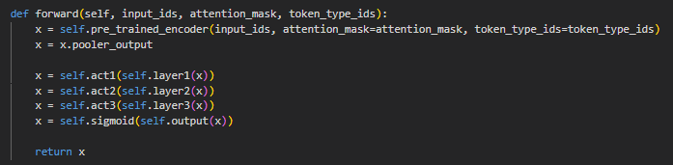

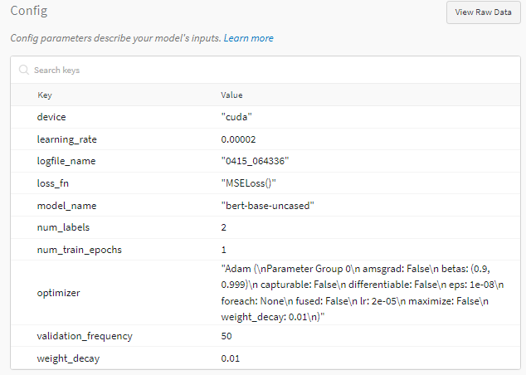
Low learning rate (2e-5) was used with Adam due to relatively large and pretrained model. Only a few epochs (1-3) were needed.

Results:
CoLA: https://wandb.ai/metrowest/bert_classification_cola
MNLI: https://wandb.ai/metrowest/bert_classification_mnli/runs/i6ahxbtv
MRPC: https://wandb.ai/metrowest/bert_classification_mrpc/runs/lnt72ir7

Colab: https://colab.research.google.com/drive/1DFy_rzecwdI_K72rbL7U56NVsn3Blq0x#scrollTo=ffP-VQOyIrJk

Git: https://github.com/cwinsor/uml_comp5300/blob/main/hw7_long_transformers/hw_bert_classification_final.ipynb

